BÁO CÁO THỰC HÀNH LAP 3  
LẬP TRÌNH HƯỚNG ĐỐI TƯỢNG

Mục lục

I. Nội dung thực hành 1

1. Branch your repository 1

2. Working with method overloading 2

3. Passing parameter 2

4. Use debug run: 4

5. Classifier Member and Instance Member 9

6. Open the Cart class 9

a. Create a new method to print the list of ordered items of a cart, the price of each item, and the total price. 9

b. Search for DVDs in the cart by ID and display the search results. 11

c. Search for DVDs in the cart by title and print the results. 12

7. Implement the Store class 13

8. Re-organize your projects 16

9. String, StringBuilder and StringBuffer 17

II. Update the use case diagram and the class diagram 19

Mục lục hình ảnh

Figure 1: Branch 3

Figure 2: Merge 3

Figure 3: addDigitalVideoDisc 4

Figure 4: swap(1) 4

Figure 5: Kết quả swap (1) 5

Figure 6: swap(2) code 5

Figure 7: swap(2) result 5

Figure 8: A breakpoint is set 5

Figure 9: The breakpoint is deleted 6

Figure 10: Deactivated breakpoint in Breakpoints View 6

Figure 11: Debug mode 7

Figure 12: Variables shown in Variable View 7

Figure 13: Step into 8

Figure 14: Step over line 21 of swap function 8

Figure 15: Step over line 22 of swap function 9

Figure 16: Step over line 23 of swap function 9

Figure 17: Change title of jungleDVD 10

Figure 18: Results 10

Figure 19: Create class attribute and instance attribute 10

Figure 20: Update the value 11

Figure 21: Code snippet for Print() methods 11

Figure 22: Code snippet for CartTest 12

Figure 23: Results 12

Figure 24: Code snippet for toString() 13

Figure 25: Code snippet for search by ID 13

Figure 26: Results 13

Figure 27: Code snippet for isMatch 14

Figure 28: Code snippet for search by title 14

Figure 29: Results 15

Figure 30: Code snippet for Store class (1) 15

Figure 31: Code snippet for Store class (2) 16

Figure 32: Code snippet for StoreTest 16

Figure 33: Results 17

Figure 34: Structure 17

Figure 35: ConcatenationInLoops 18

Figure 36: GarbageCreator 18

Figure 37: NoGarbage (1) 19

Figure 38: NoGarbage (2) 19

Figure 39: Class Diagram update 20

# Nội dung thực hành

## Branch your repository

Create new branch: git checkout -b name

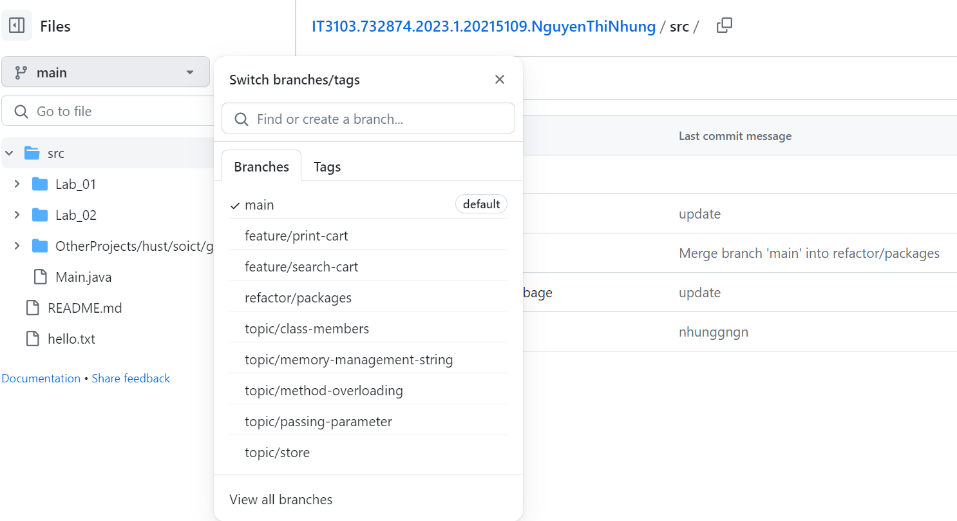

Figure : Branch

Merge the remote branch to the main branch:

Figure : Merge

## Working with method overloading

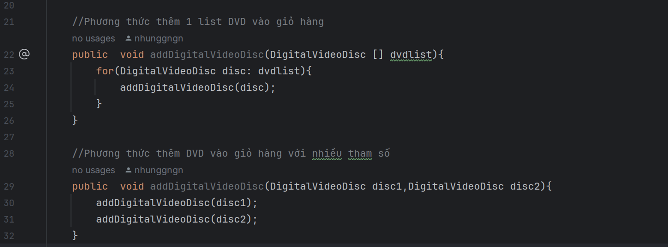

Figure : addDigitalVideoDisc

## Passing parameter

Mã nguồn ban đầu:

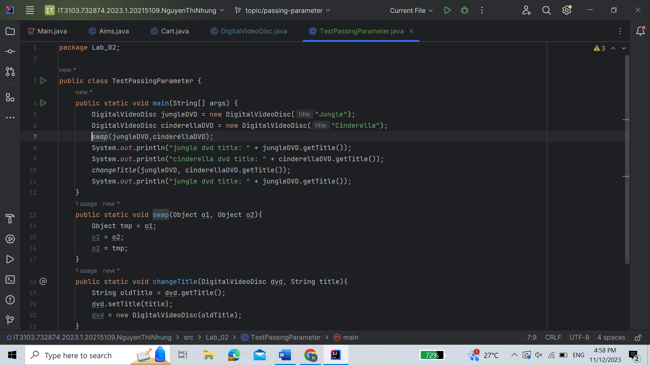

Figure : swap(1)

Kết quả:

Figure : Kết quả swap (1)

Mã nguồn mới:

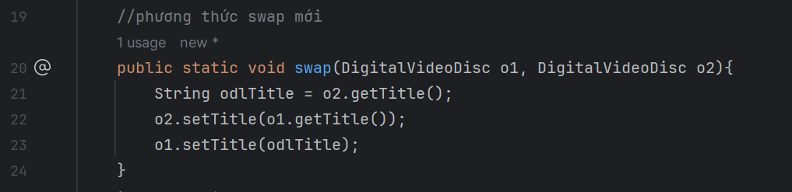

Figure : swap(2) code

Kết quả:

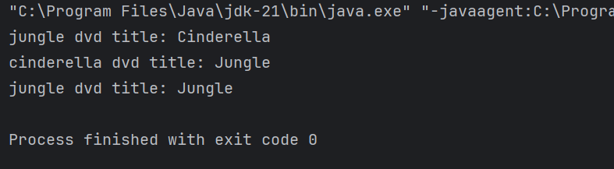

Figure : swap(2) result

## Use debug run:

Figure : A breakpoint is set

Figure : The breakpoint is deleted

Figure : Deactivated breakpoint in Breakpoints View

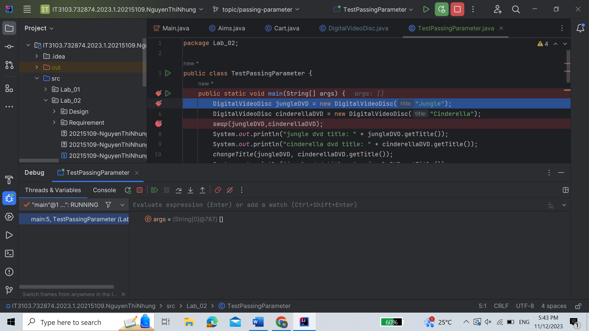

Figure : Debug mode

Figure : Variables shown in Variable View

Figure : Step into

Figure : Step over line 21 of swap function

Figure : Step over line 22 of swap function

Figure : Step over line 23 of swap function

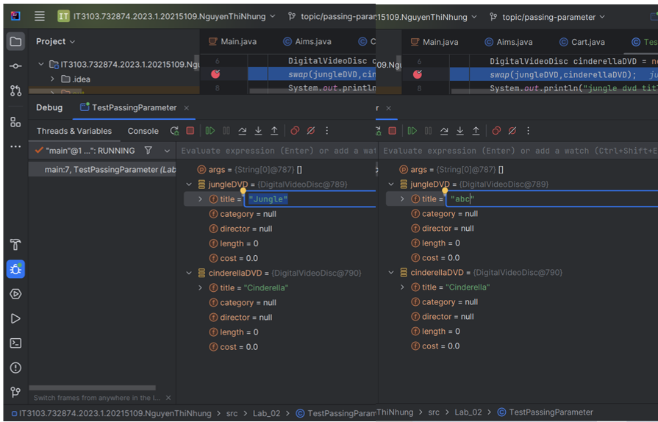

Figure : Change title of jungleDVD

Figure : Results

## Classifier Member and Instance Member

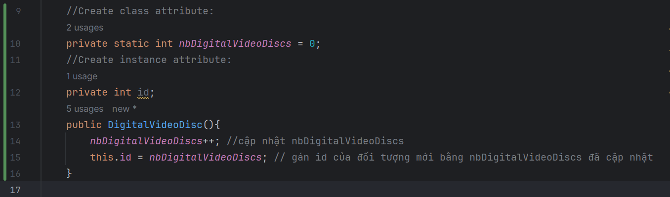

Figure : Create class attribute and instance attribute

Figure : Update the value

## Open the Cart class

### Create a new method to print the list of ordered items of a cart, the price of each item, and the total price.

Figure : Code snippet for Print() methods

Figure : Code snippet for CartTest

Figure : Results

### Search for DVDs in the cart by ID and display the search results.

Figure : Code snippet for toString()

Figure : Code snippet for search by ID

Figure : Results

### Search for DVDs in the cart by title and print the results.

Figure : Code snippet for isMatch

Figure : Code snippet for search by title

Figure : Results

## Implement the Store class

Mã nguồn:

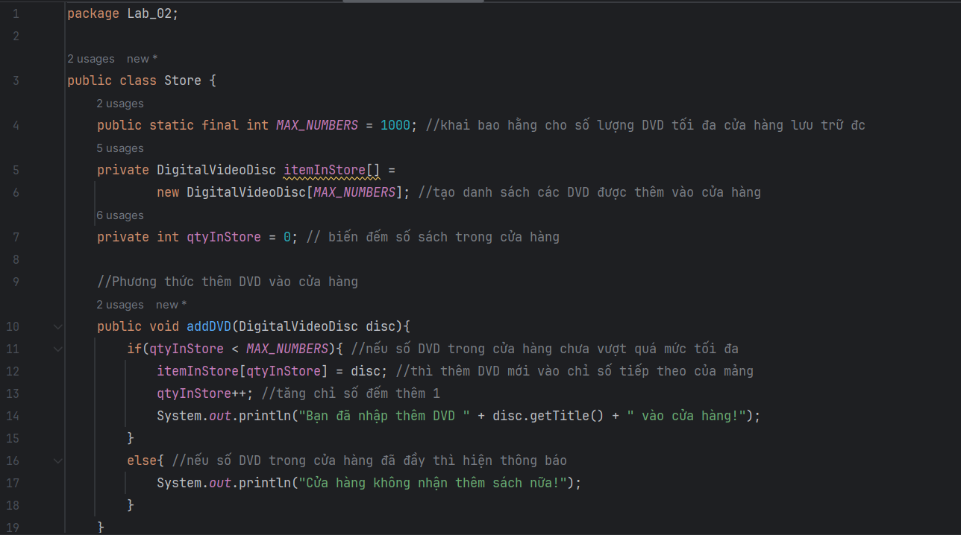

Figure : Code snippet for Store class (1)

Figure : Code snippet for Store class (2)

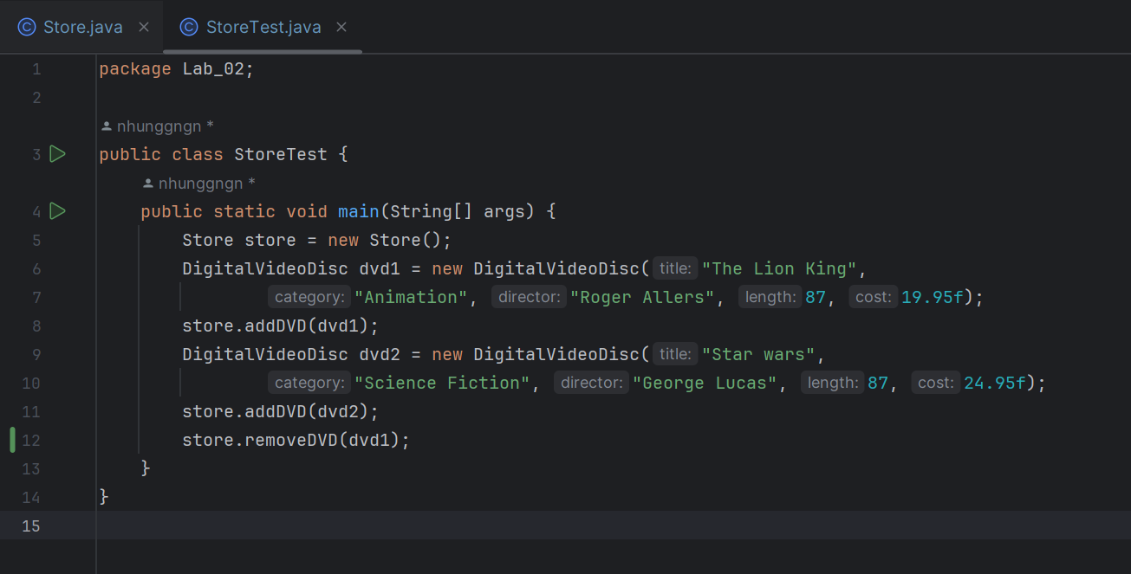

Figure : Code snippet for StoreTest

Kết quả:

Figure : Results

## Re-organize your projects

Figure : Structure

## String, StringBuilder and StringBuffer

Figure : ConcatenationInLoops

Figure : GarbageCreator

Figure : NoGarbage (1)

Figure : NoGarbage (2)

# Update the use case diagram and the class diagram

Figure : Class Diagram update